THAMES VALLEY NETWORK
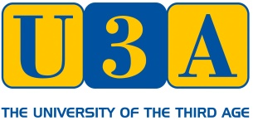

SWEET THAMES STUDY DAY
THE RIVER & ROWING MUSEUM, HENLEY-ON-THAMES, RG9 1BF
WEDNESDAY, 18TH MARCH, 2020
APPLICATION FORM
(Please complete in block capitals – one form per person)

I would like to attend the study day on Wednesday, 18th March, 2020

Full Name ………………………………………………………………………………

Email………………………………………………………………………………………

Telephone number ……………………………………………..

Fee £13:00 to TVN members, £15:00 for non TVN members

The fee includes the use of the Thames Room all day for a full programme of talks; free parking on site; free entry to the Museum (normal entry fee £10) and refreshments on arrival. It does NOT include lunch. A long lunch hour is built in to the programme to enable participants to explore the Museum, enjoy a picnic lunch by the river or take a meal in the Museum restaurant or in one of the local pubs.

I enclose a cheque for £…………made payable to: U3A Thames Valley Network

I certify that I belong to ………….…………………………………………………U3A

I would like to receive details of future TVN events by email YES / NO
(New data protection regulations require you to consent to your email address being held by TVN. Without it we cannot retain it or send you information for any event other than this one.)

Signed………………………………………………………Date …………………..

Application should be sent to:

Mrs PA Thornton, 6 Highway, Crowthorne, Berks, RG45 6HE (Tel: 01344 774812)

Acknowledgement will be sent by email, unless a stamped self-addressed envelope
is provided.

